Thompson Communications
PRESS RELEASE

For Immediate Release

Press Contact:
Steve Thompson
steve@thomcomm.com
856-571-6796

Producer Patrick Jerome Presents "Assassin Behind the Glass," In Multi-Platform Streaming Release
(April, 2019 -- Boston, MA) Assassin Behind the Glass is a contemporary urban story that questions whether “snitching” is an honorable virtue, a death sentence, or perhaps a little bit of both.
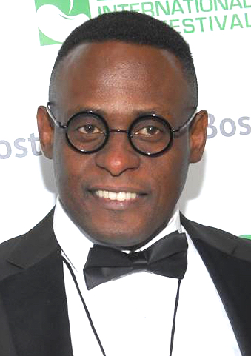
Producer Patrick Jerome explains: “I had been to the Dorchester, MA Post Office many times for routine business, and became acquainted with the people who work there. One day a thick, bulletproof glass barrier was erected at the counter, so I asked why. Turns out an incident had taken place there, and the barrier was installed as a security measure. It occurred to me that this was a story that needed to be examined. That story became Assassin Behind the Glass.”
Producer Patrick Jerome
Patrick hopes that the message that audiences take away from Assassin Behind the Glass is twofold: One, that each of us needs to use our own situational discretion when deciding whether or not to say something if we see something; and second, that the problem of gun violence in society needs to be examined on a deeper level than is currently being assessed.

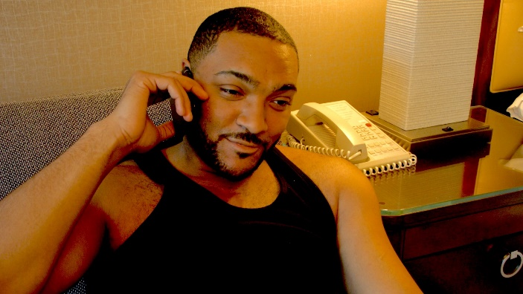

Langston Fishburne as Sean
The film stars Langston Fishburne, the adult son of star Laurence Fishburne (The Matrix, The Tuskegee Airmen, Mystic River) who happens to be a dead ringer for his pop.
Fishburne, who portrays the lead character of Sean, was drawn to the idea of a black story unfolding in Boston, when the majority of films depicting stories in the area focus on the Irish or Italian communities.
What attracted Fishburne to the film was a script (penned by Jerome) that casts an honest light on black crime.
“It isn’t romanticized,” Fishburne maintains. “It’s harsh and in-your-face, and I loved performing that aspect of it. This film makes you think, as a black man, about what it’s like to love that sort of criminal life and have that be the backdrop of your reality.”
The film also features Chandra Thomas, Scott Neufville, and Lonnie Farmer.
A successful screening in The Boston International Film Festival on April 13 is now followed by the online streaming and on-demand release of the film on iTunes, Amazon, Hulu, Redbox, Google Play, Playstation Network, Hoopla, Tubi, FandangoNOW, Kanopy, SlingTV, iDemand, and Patrick continues to work to bring the film to an even wider audience.
# # # #

Patrick Jerome is available for interview
By appointment, pending availability

Contact Steve Thompson
steve@thomcomm.com
cell: 856-571-6796

Additional Press Materials for Patrick Jerome

